DP Series
Pure Sine Wave Inverter/Charger
User’s Manual
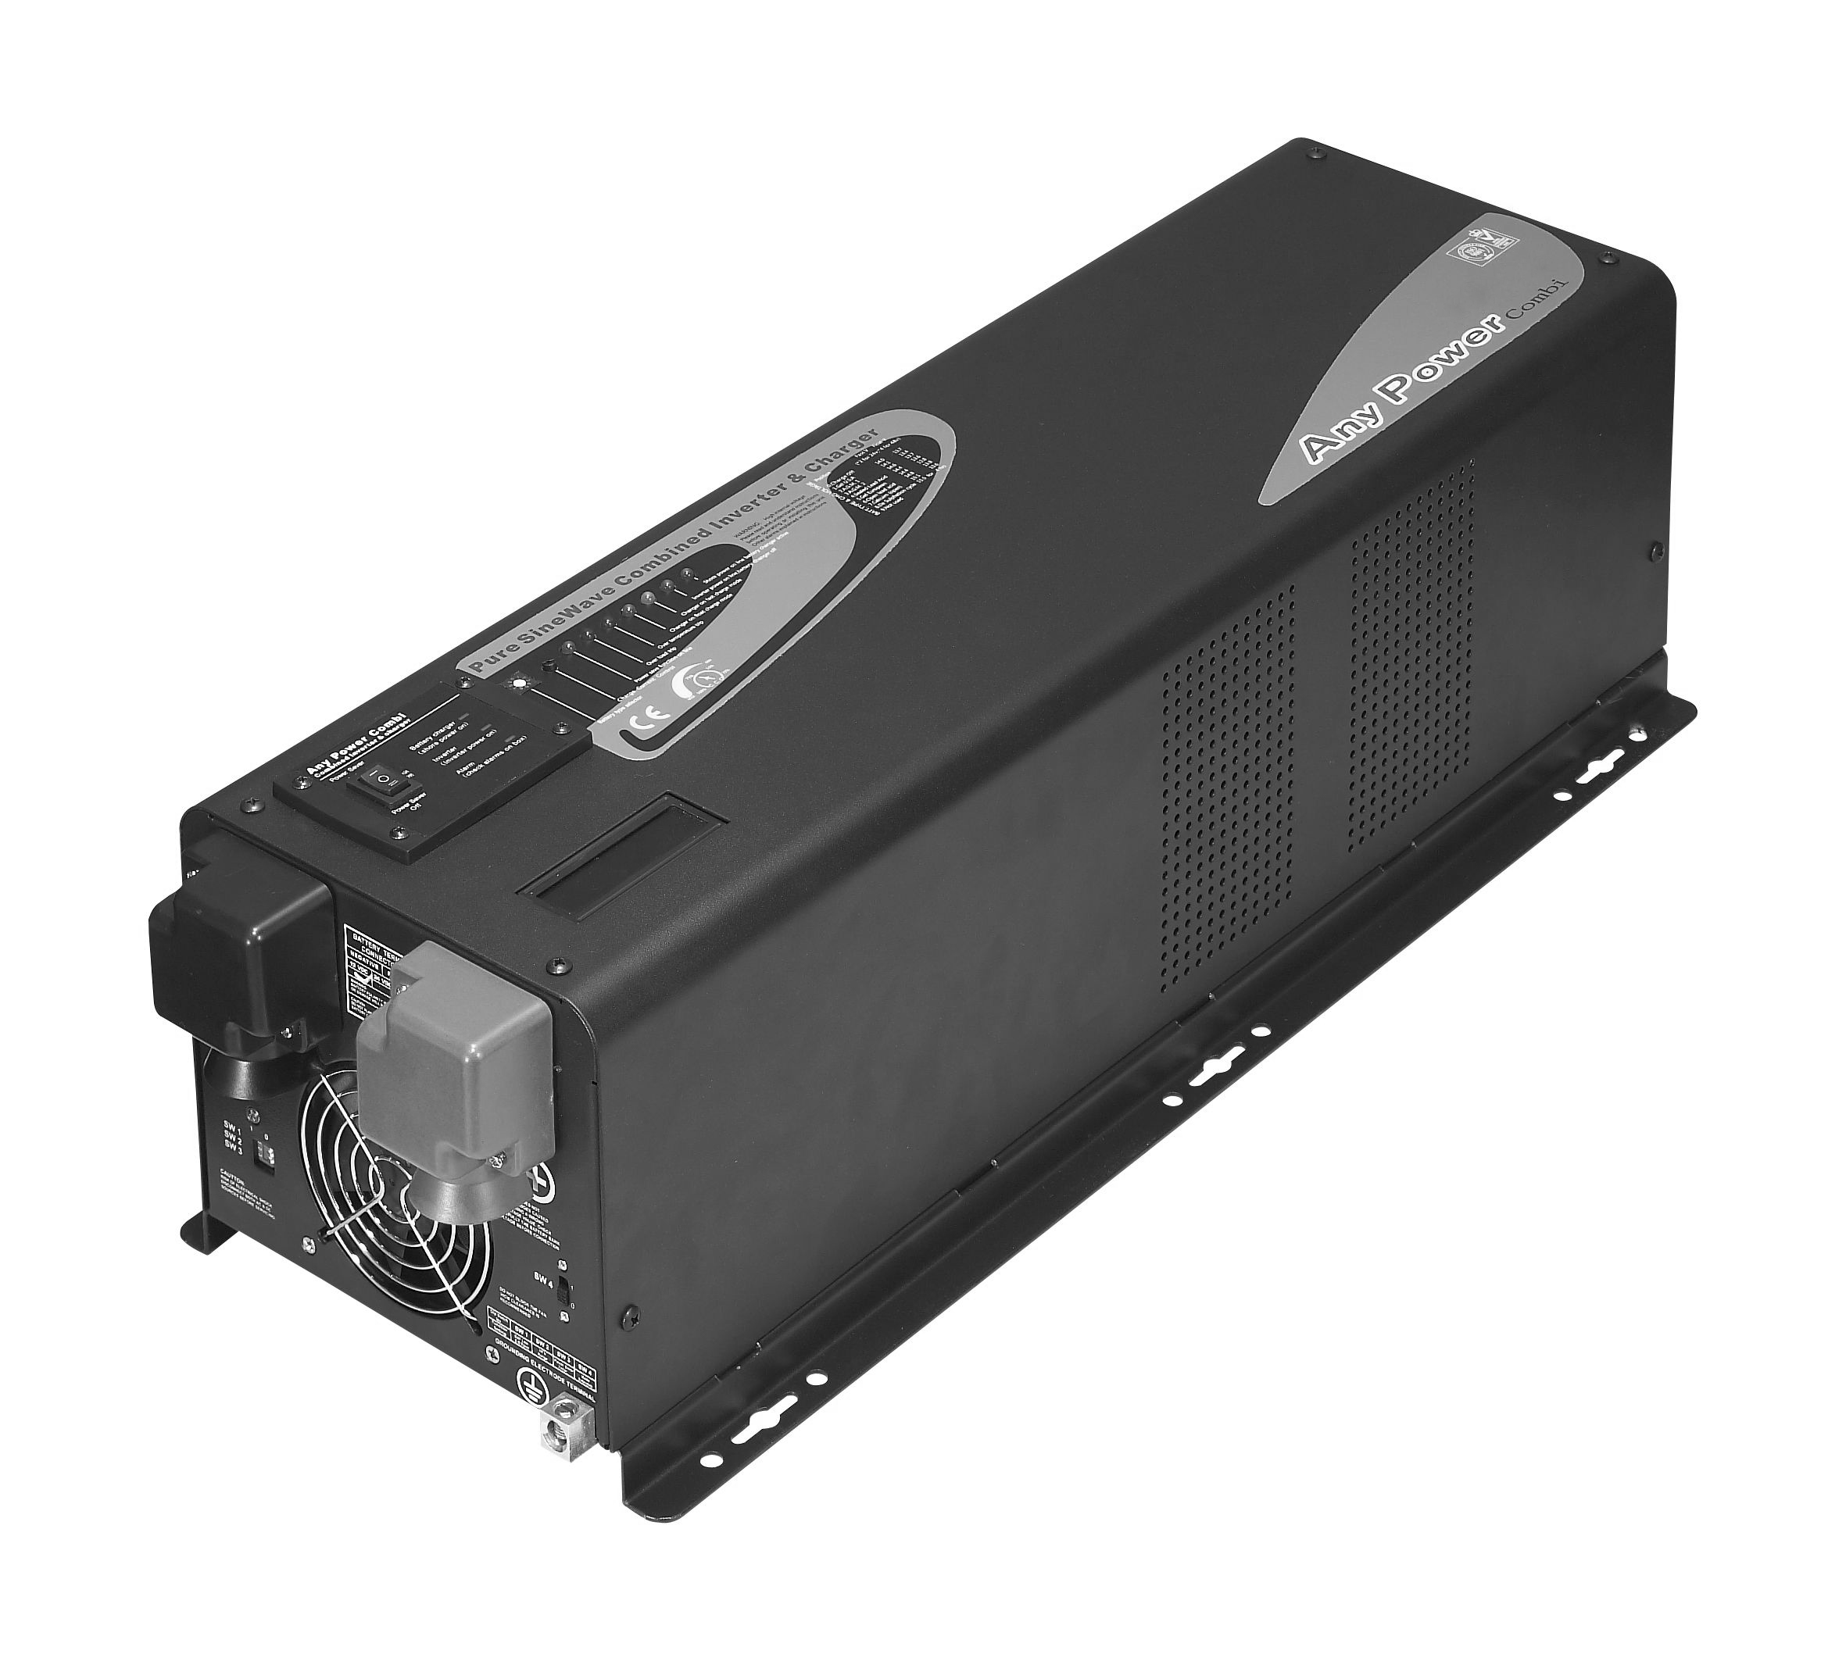
Table of Contents
1. Important Safety Information 3
1.1 General Safety Precautions 3
1.2 Precautions When Working with Batteries 3
2. Introduction 4
2.1 General Information 4
2.2 Application 5
2.3 Features 5
2.4 Mechanical Drawing 6
2.5 Electrical Performance 8
2.5.1 Invert 8
2.5.2 AC Charger 8
2.5.3 Transfer 12
2.5.4 Auto frequency adjust 12
2.5.5 Automatic Voltage Regulation* 12
2.5.6 Power Saver 13
2.5.7 Protections 15
2.5.8 Remote control 15
2.5.9 LED Indicator & LCD 16
2.5.10 Audible Alarm 17
2.5.11 FAN Operation 18
2.5.12 DIP Switches 18
2.5.13 Other features 20
3 Installation 20
3.1 Unpacking and Inspection 20
3.2 Installation Location 21
3.3 DC Wiring 21
3.4 AC Wiring 23
3.5 Grounding 24
3.6 Mounting the Inverter 24
4 Troubleshooting Guide 26
5 Warranty 28
6 Model Numbering 29
Appendix 1 DP Series Inverter&Charger 29

Please record the unit’s model and serial number in case you need to provide this information in the future. It is much easier to record this information now than try to gather it after the unit has been installed.

Model Number:

Serial Number:

1. Important Safety Information
Save This Manual! Read this manual before installation, it contains important safety, installation and operating instructions. Keep it in a safe place for future reference.
All wiring must follow the National Electric Code, Provincial or other codes in effect at the time of installation, regardless of suggestions in this manual. All wires should be copper conductors.

1.1 General Safety Precautions
1.1.1 Do not expose the Inverter to rain, snow, spray, bilge or dust. To reduce risk of hazard, do not cover or obstruct the ventilation openings. Do not install the Inverter in a zero-clearance compartment. Overheating may result. Allow at least 30CM of clearance around the inverter for air flow. Make sure that the air can circulate freely around the unit. A minimum air flow of 145CFM is required.
1.1.2 To avoid risk of fire and electronic shock, make sure that existing wiring is in good electrical condition and that the wire is not undersized. Do not operate the Inverter with damaged or substandard wiring.
1.1.3 This equipment contains components which may produce arcs and/or sparks. To prevent fire and/or explosion do not install in compartments containing batteries or flammable materials or in a location which require ignition protected equipment. This includes any space containing gasoline-powered machinery, fuel tanks, or joints, fittings, or other connection between components of the fuel system.
See Warranty for instructions on obtaining service.
1.1.4 Do not disassemble the Inverter/Charger. It contains no user-serviceable parts. Attempting to service the Inverter/Charger yourself may result in electrical shock or fire. Internal capacitors remain charged after all power is disconnected.
1.1.5 To reduce the risk of electrical shock, disconnect both AC and DC power from the Inverter/Charger before attempting any maintenance or cleaning. Turning off controls will not reduce this risk
CAUTION: Equipment damage
The output side of the inverter’s AC wiring should at no time be connected to public power or a generator. This condition is far worse than a short circuit. If the unit survives this condition, it will shut down until corrections are made.
Installation should ensure that the inverter’s AC output is, at no time, connected to its AC input.
Warning: Limitations Of Use
SPECIFICALLY, PLEASE NOTE THAT THE INVERTER/CHARGER SHOULD NOT BE USED IN CONNECTION WITH LIFE SUPPORT SYSTEMS OR OTHER MEDICAL EQUIPMENT OR DEVICES. WE make no warranty or representation in connection with their products for such uses. Using the Inverter/Charger with this particular equipment is at your own risk.

1.2 Precautions When Working with Batteries
1.2.1 If battery acid contacts skin or clothing, wash immediately with soap and water. If acid enters eye, immediately flood eye with running cold water and get medical attention immediately.
1.2.2 Never smoke or allow a spark or flame in the vicinity of a battery or engine.
1.2.3 Do not drop a metal tool on the battery. The resulting spark or short-circuit on the battery may cause an explosion.
1.2.4 Remove personal metal items such as rings, bracelets, necklaces, and watches when working with a lead-acid battery. A lead-acid battery produces a short-circuit current high enough to weld a ring or the like to metal, causing a severe burn.
1.2.5 To reduce the risk of injury, charge only deep-cycle lead acid, lead antimony, lead calcium gel cell, absorbed mat, or NiCad/NiFe type rechargeable batteries. Other types of batteries may burst, causing personal injury and damage.

2. Introduction

2.1 General Information
DP Series Pure Sine Wave Inverter/Charger is a combination of an inverter, battery charger and AC auto-transfer switch into one complete system with a peak DC to AC conversion efficiency of 88%.
It is packed with unique features and it is one of the most popular and affordable inverter/chargers in the market today.
It features power factor corrected, sophisticated multi-stage charging and pure sine wave output with unprecedentedly high surge capability to meet demanding power needs of inductive loads without endangering the equipment.
The powerful battery charger of this Series Inverter/Charger goes as high as 105Amps (varying on different models), and with power factor corrected, it uses 20-30% less energy from AC input than a standard charger, avoiding nuisance breaker trips or generator overloads.
The overload capacity is 300% of continuous output for up to 20 seconds to reliably support tools and equipment longer.
The idle consumption of the line is low, roughly 4% of its rated power.
These special features make this line compete very well with its high frequency counterparts.
The models are available in 120Vac (single phase), 230Vac (single phase) and 120/240Vac (split phase), together with automatic 50Hz/60Hz frequency switch, the product line is compatible with all the major utility standards worldwide.
This line includes some exclusive 4KW 12Vdc models enable vehicle users to power ample loads at a 12VDC battery bank without reconfiguration of their battery bank.
The AC/Battery priority switch and auto generator start functionality make it ideally suitable to work in either backup power or renewable energy applications.
In AC priority mode, when AC power cuts off (or falls out of acceptable range), the transfer relay is de-energized and the load is automatically transferred to the Inverter output. Once the qualified AC power is restored, the relay is energized and the load is automatically reconnected to AC utility.
When customized to Battery Priority Mode via a DIP switch, the inverter will extract maximum power from external power sources in renewable energy systems and a minimal cycle of battery will be required. With the availability of auto generator start, an electrical generator can be integrated into the system as back up and started when the battery voltage goes low.
With audible buzzer and a remote LED display, the inverter gives the users comprehensive information of the operation status, making it easier for maintenance and troubleshooting.
Thus the DP Series Pure Sine Wave Inverter/Charger is suitable for a myriad of applications including renewable energy systems, utility, truck, RV and emergency vehicles etc.
To get the most out of the power inverter, it must be installed, used and maintained properly. Please read the instructions in this manual before installing and operating.

2.2 Application
Power tools–circular saws, drills, grinders, sanders, buffers, weed and hedge trimmers, air compressors.
Office equipment – computers, printers, monitors, facsimile machines, scanners.
Household items – vacuum cleaners, fans, fluorescent and incandescent lights, shavers, sewing machines.
Kitchen appliances – coffee makers, blenders, ice markers, toasters.
Industrial equipment – metal halide lamp, high – pressure sodium lamp.
Home entertainment electronics – television, VCRs, video games, stereos, musical instruments, satellite equipment.

2.3 Features
High overload ability up to 300% of rated power (20 sec)
Low quiescent current, low power “Power Saving Mode” to conserve energy
Automatic Generator Start
4-step intelligent battery charger, PFC (Power Factor Correction) for charger
8 pre-set battery type selector switch plus de-sulphation for totally flat batteries
Powerful charge rate of up to 120Amps, selectable from 0%-100%
10 ms typical transfer time between battery and AC, guarantees power continuity
Smart LED remote control panel
AC voltage regulation available
15s delay before transfer when AC resumes, extra protection for loads when used with generator
Allows start up and through power with depleted batteries
Multiple controlled cooling fans
Extensive protections against various harsh situations
13VDC battery recovery point, dedicated for renewable energy systems
2.4 Mechanical Drawing
DC DIDE FOR DP 1KW TO 6KW MODELS
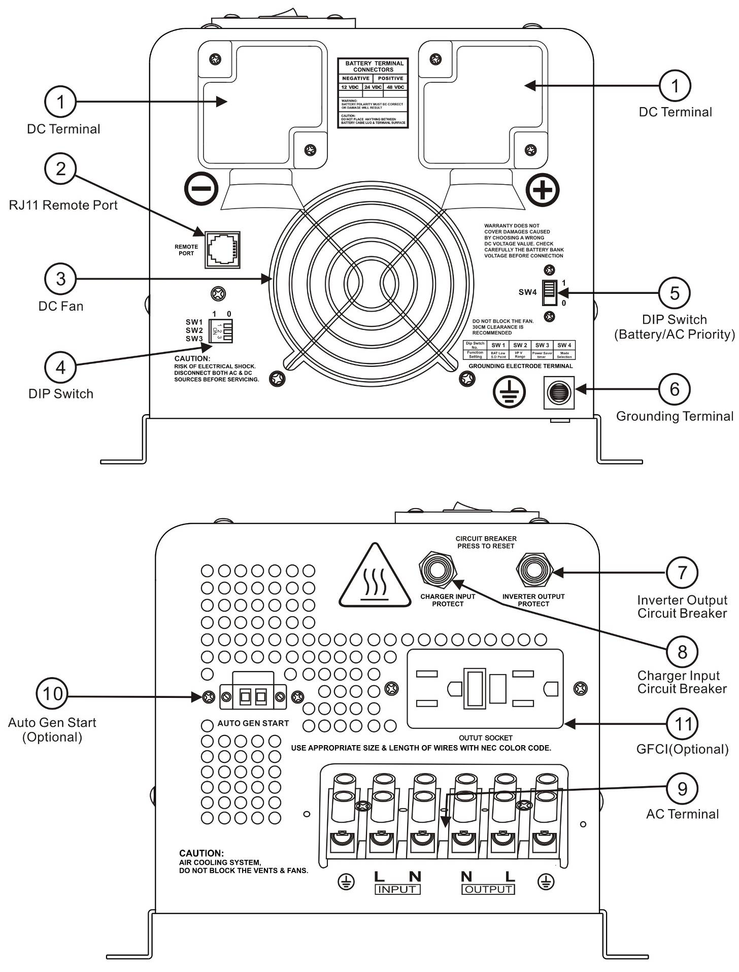

External Components Introduction
1 DC Terminals
2 RJ11 Port for Remote Control Panel
3 DC Fan
4 SW1/SW2/SW3 DIP Switches
5 SW4 DIP Switch
6 Grounding Terminal
7 Inverter Output Protection Circuit Breaker
8 Charger Input Protection Circuit Breaker
9 AC Terminal Block
10 Auto Generator Start Terminal(Optional)
11 AC Fan/GFCI

AC DIDE FOR DP 1KW TO 3KW MODELS

AC DIDE FOR DP 4KW TO 6KW MODELS
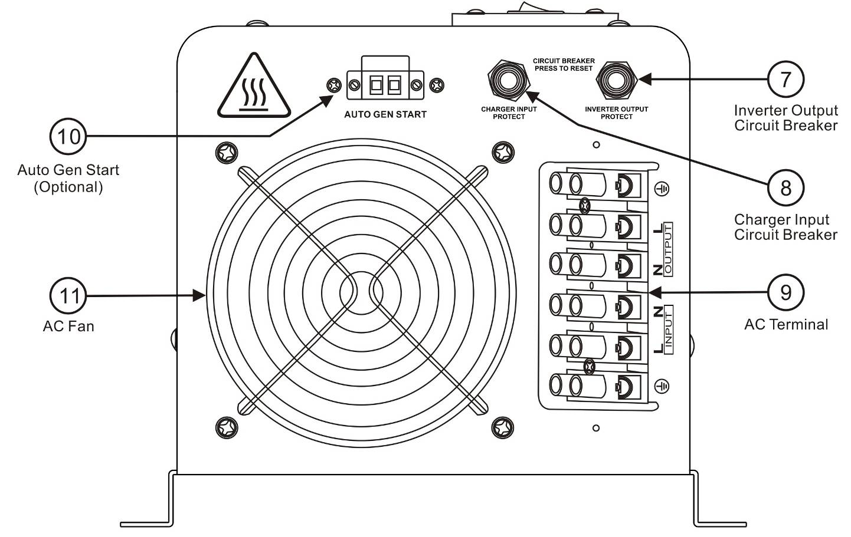
2.5 Electrical Performance

2.5.1 Invert
Topology
The DP inverter/charger is built according to the following topology.
Invert: Full Bridge Topology.
Charge: Isolated Boost Topology.
It works bi-directionally: in one direction it converts DC power from the battery to AC power (Inverter Mode) and in the other direction it converts external AC power to DC power to charge the batteries (AC Mode). The same power components are used in both directions, resulting in high-energy transfer efficiency with fewer components.
Please note that the inverter/charger can only work in one direction at one time (i.e. it can not work as an inverter and as a charger at the same time).
When operating in invert mode, the direct current (DC) that enters the inverter from the batteries is filtered by a large input capacitor and switched “On” and “Off” by the Metal Oxide Silicon Field Effect Transistors (MOSFET) at a rate of 50 Hz or 60Hz, in this step the DC is converted to low voltage synthesized sine wave AC using an H-bridge configuration and high frequency PWM (Pulse Width Modulation) technique. It is then directed into the transformer which steps the low AC voltage up to 230 or 120 volts.
The unit has a 16bit, 4.9MHZ microprocessor to control the output voltage and frequency as the DC input voltage and/or output load varies.
Because of high efficiency MOSFETs and the heavy transformers, it outputs PURE SINE WAVE AC with low THD.
The peak efficiency of DP series is 88%.
Don’t parallel the AC output of the inverters to increase power capacity as they have no stacking functionality.

Overload Capacity
The DP series inverters have different overload capacities, making it ideal to handle demanding loads.
1 For 110%<Load<125%(±10%), no audible alarm in 14 minutes, beeps 0.5s every 1s in the 15th minute, and Fault(Turn off) after the 15th minute.
2 For 125%<Load<150%(±10%), beeps 0.5s every 1s and Fault(Turn off) after the 1 minute.
3 For 300%≧Load>150%(±10%), beeps 0.5s every 1s and Fault(Turn off) after 20s.

Soft Start in Inverter Mode
The inverter is engineered with “Soft Start” feature.
When the inverter is turned on, the output voltage gradually ramps up from 0VAC to rated voltage in about 1.2 sec. This effectively reduces otherwise very high starting inrush current drawn by AC loads such as Switched Mode Power Supplies and inductive loads. This will result in lower motor inrush current, which means less impact on the loads and inverter.

2.5.2 AC Charger
DP Series is equipped with an active PFC (Power Factor Corrected) multistage battery charger. The PFC feature is used to control the amount of power used to charge the batteries in order to obtain a power factor as close as possible to 1.
Unlike other inverters whose max charging current decreases according to the input AC voltage, DP series charger is able to output max current as long as input AC voltage is in the range of 164-243VAC(95-127VAC for 120V model), and AC freq is in the range of 48-54Hz(58-64Hz for 60Hz model).
The DP series inverter has a very rapid charge current available, and the max charge current can be adjusted from 0%-100% via a liner switch to the right of the battery type selector. This will be helpful if you are using our powerful charger on a small capacity battery bank. Fortunately, the liner switch can effectively reduce the max charging current to 20% of its peak.
Choosing “0” in the battery type selector will disable charging function.

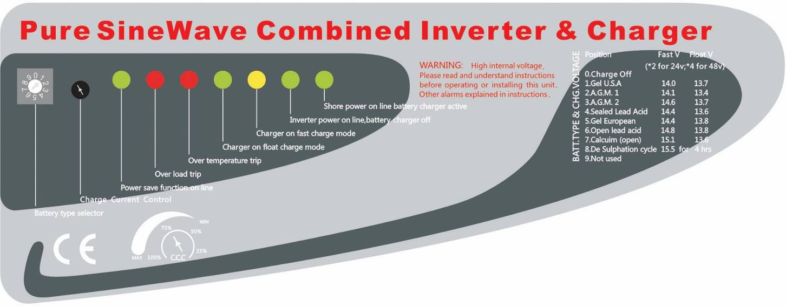

There are 3 main stages:
Bulk Charging: This is the initial stage of charging. While Bulk Charging, the charger supplies the battery with controlled constant current. The charger will remain in Bulk charge until the Absorption charge voltage (determined by the Battery Type selection) is achieved.
Software timer will measure the time from A/C start until the battery charger reaches 0.3V below the boost voltage, then take this time asT0 and T0×10 = T1.
Absorb Charging: This is the second charging stage and begins after the absorb voltage has been reached. Absorb Charging provides the batteries with a constant voltage and reduces the DC charging current in order to maintain the absorb voltage setting.
In this period, the inverter will start a T1 timer; the charger will keep the boost voltage in Boost CV mode until the T1 timer has run out. Then drop the voltage down to the float voltage. The timer has a minimum time of 1 hour and a maximum time of 12 hours.
Float Charging: The third charging stage occurs at the end of the Absorb Charging time. While Float charging, the charge voltage is reduced to the float charge voltage (determined by the Battery Type selection*). In this stage, the batteries are kept fully charged and ready if needed by the inverter.
If the A/C is reconnected or the battery voltage drops below 12Vdc/24Vdc/48Vdc, the charger will reset the cycle above.
If the charge maintains the float state for 10 days, the charger will deliberately reset the cycle to protect the battery.
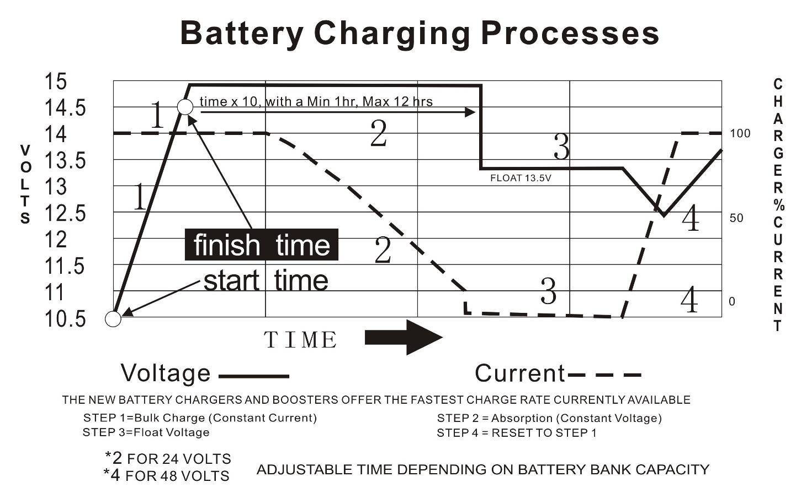

Battery type selector
Switch setting | Description | Boost / Vdc | Float / Vdc
0 | Charger Off
1 | Gel USA | 14.0 | 13.7
2 | AGM 1 | 14.1 | 13.4
3 | AGM 2 | 14.6 | 13.7
4 | Sealed lead acid | 14.4 | 13.6
5 | Gel EURO | 14.4 | 13.8
6 | Open lead acid | 14.8 | 13.3
7 | Calcium | 15.1 | 13.6
8 | De sulphation | 15.5 (4 Hours then Off)
9 | Not used
12Vdc Mode (*2 for 24Vdc ; *4 for 48Vdc)

De-sulphation
The de-sulphation cycle on switch position 8 is marked in red because this is a very dangerous setting if you do not know what you are doing. Before ever attempting to use this cycle you must clearly understand what it does and when and how you would use it.
What causes sulphation? This can occur with infrequent use of the batteries, nor if the batteries have been left discharged so low that they will not accept a charge. This cycle is a very high voltage charge cycle designed to try to break down the sulphated crust that is preventing the plates from taking a charge and thus allow the plates to clean up and accept a charge once again.

Charging depleted batteries
The DP series inverter allows start up and through power with depleted batteries.
For 12VDC model, after the battery voltage goes below 10V, if the switch is still(and always) kept in "ON" position, the inverter is always connected with battery, and the battery voltage doesn’t drop below 2V, the inverter will be able to charge the battery once qualified AC inputs.
Before the battery voltage going below 9VDC, the charging can activated when the switch is turned to “Off”, then to “ON”.
When the voltage goes below 9VDC, and you accidently turn the switch to OFF or disconnect the inverter from battery, the inverter will not be able to charge the battery once again, because the CPU lose memory during this process.
Start up without battery function can be customized upon request.

Charging current for each model

Model | Current | Model | Current
1KW12V230V | 35+/-5A | 1KW12V120V | 35+/-5A
1KW24V230V | 20+/-5A | 1KW24V120V | 15+/-5A
1.5KW12V230V | 45+/-5A | 1.5KW12V120V | 50+/-5A
1.5KW24V230V | 25+/-5A | 1.5KW24V120V | 30+/-5A
2KW12V230V | 65+/-5A | 2KW12V120V | 70+/-5A
2KW24V230V | 30+/-5A | 2KW24V120V | 30+/-5A
2KW48V230V | 20+/-5A | 2KW48V120V | 20+/-5A
3KW12V230V | 85+/-5A | 3KW12V120V | 100+/-5A
3KW24V230V | 45+/-5A | 3KW24V120V | 40+/-5A
3KW48V230V | 30+/-5A | 3KW48V120V | 25+/-5A
4KW12V230V | 115+/-5A | 4KW12V120V | 115+/-5A
4KW24V230V | 65+/-5A | 4KW24V120V | 50+/-5A
4KW48V230V | 35+/-5A | 4KW48V120V | 30+/-5A
5KW24V230V  5KW24V230V(Split Phase) | 70+/-5A
5KW48V230V  5KW48V230V(Split Phase) | 50+/-5A
6KW24V230V  6KW24V230V(Split Phase) | 85+/-5A
6KW48V230V  6KW48V230V(Split Phase) | 60+/-5A

The charging capacity will go to peak charge rate in about 3 seconds. This may cause a generator to drop frequency, making the inverter transfer to battery mode.
It is suggested to gradually put the charging load on the generator by switching the charging switch from min to max. Together with the 15s switch delay our inverter gives the generator enough time to spin up. This will depend on the size of the generator and rate of charge.
As a general Rule, the Bulk Charging Current should be limited to 30% of the capacity of the battery bank. Higher charging current may be used if permitted by the battery manufacturer.

Caution: | Please use a small jeweler’s style flat-head screwdriver to turn the charge current control switch gently to avoid breakage due to over-turning.  To guarantee the best performance of AC charger when the AC input is from a generator, the standby generator should be of at least 150% higher capacity than the inverter.  Warning! Operation with an under-rated generator or generator with unqualified wave form may cause premature failure which is not under warranty.

2.5.3 Transfer
Swift Power Transfer
While in the Standby Mode, the AC input of the inverter is continually monitored. Whenever AC power falls below the low AC voltage trip voltage (154 Vac, default setting for 230VAC,90VAC for 120VAC), the inverter automatically transfers back to the Invert Mode with minimum power interruption to your appliances - as long as the inverter is turned on. The transfer from Standby mode to Inverter mode occurs in approximately 10 milliseconds. And it is even shorter from Inverter mode to Standby mode.
This transfer time is usually fast enough to keep your equipment (including computers) powered up, thus our inverter can be used as a line interactive UPS.

Synchronized Power Transfer
When a load is transferred from inverter AC output to another backup AC source of power through a transfer switch, there will be a finite interruption of power to the load for the transfer to take place.
A mismatch of phase and frequency of the inverter AC output and the backup AC source in transfer is likely to damage the backup AC source / a reactive load.
With sophisticated circuitry design, our inverter will first lock on the frequency and phase of the input shore power/generator power and make a smooth and safe transfer at the zero voltage point to minimize the impact on the power modules.

Transfer Delay
There is a 15-second delay from the time the inverter senses that continuously qualified AC is present at the input terminals to when the transfer is made. This delay is built in to provide sufficient time for a generator to spin-up to a stable voltage and frequency and avoid relay chattering. The inverter will not transfer to generator until it has locked onto the generator’s output. This delay is also designed to avoid frequent switching when input utility is unstable.

2.5.4 Auto frequency adjust
The inverter is designed with Auto Frequency adjust function.
The factory default configuration for 220/230/240VAC inverter is 50Hz, and 60Hz for 100/110/120VAC inverter.
While the output freq can be easily changed once a qualified freq is applied to the inverter.
If you want to get 60Hz from a 50Hz inverter, just input 60Hz power, and the inverter will automatically adjust the output freq to 60Hz and vice versa.

2.5.5 Automatic Voltage Regulation*
The automatic voltage regulation function is available for DPS series Pure Sine Wave Inverter/ Charger which is a combination of DP inverter and Automatic Voltage Regulator.
Instead of simply bypassing the input AC to power the loads, the DPS series inverter stabilizes the input AC voltage to a range of 230V/120V±10%.
Connected with batteries, the DPS inverter will function as a UPS with max transfer time of 10 ms.
With all the unique features from the inverter and AVR, it brings you long-term trouble free operation beyond your expectation.
DPS Series AVR Function Introduction
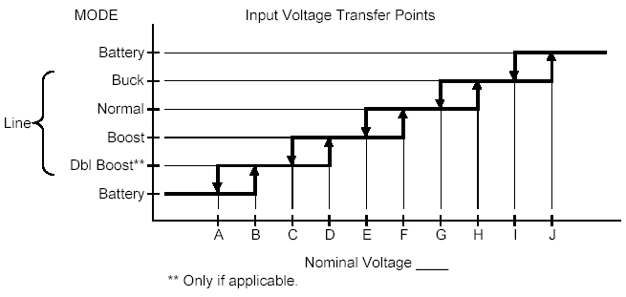

Nominal Input Voltages (Vac) | 100 | 110 | 120 | 220 | 230 | 240
Acceptable Input Voltage Range (Vac) | 0-160 |  |  | 0-300
(A) Line low loss N/W (On battery) | 75/65 | 84/72 | 92/78 | 168/143 | 176/150 | 183/156
(B) Line Low comeback N/W (On Boost) | 80/70 | 89/77 | 97/83 | 178/153 | 186/160 | 193/166
(C) Line 2nd boost threshold (On Boost) | ** | ** | ** | ** | ** | **
(D) Line 2nd boost comeback (On normal) | ** | ** | ** | ** | ** | **
(E) Line 1st boost threshold (On Boost) | 90 | 99 | 108 | 198 | 207 | 216
(F) Line 1st boost comeback (On normal) | 93 | 103 | 112 | 205 | 215 | 225
(G) Line buck comeback (On Normal) | 106 | 118 | 128 | 235 | 246 | 256
(H) Line buck threshold (On Buck) | 110 | 121 | 132 | 242 | 253 | 264
(I) Line high comeback (On Buck) | 115 | 127 | 139 | 253 | 266 | 278
(J) Line high loss (On Battery) | 120 | 132 | 144 | 263 | 276 | 288

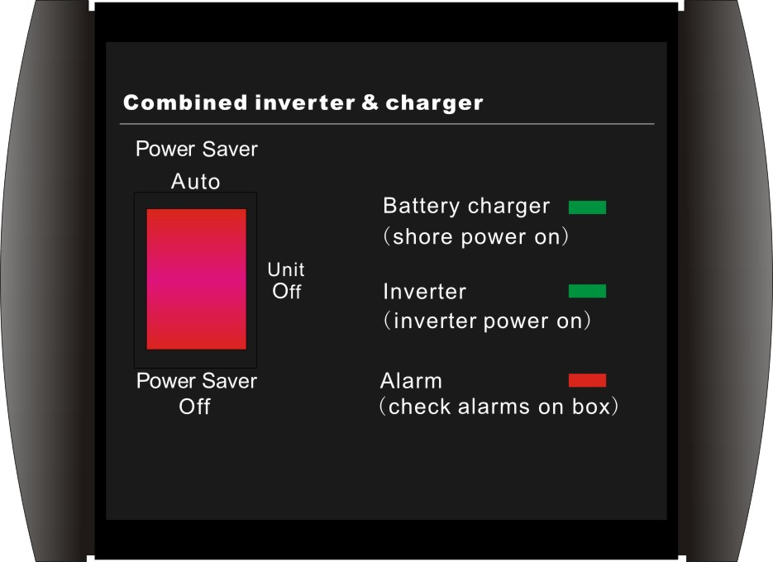
2.5.6 Power Saver
There are 2 different working statuses for DP inverter: “Power On” and “Power Off”.
When power switch is in “Unit Off” position, the inverter is powered off.
When power switch is turned to either of “Power Saver Auto” or “Power Saver Off”, the inverter is powered on.
Power saver function is to dedicated to conserve battery power when AC power is not or little required by the loads.
In this mode, the inverter pulses the AC output looking for an AC load (i.e., electrical appliance). Whenever an AC load (greater than 25 watts) is turned on, the inverter recognizes the need for power and automatically starts inverting and output goes to full voltage. When there is no load (or less than 25 watts) detected, the inverter automatically goes back into search mode to minimize energy consumption from the battery bank.
In “Power saver on” mode, the inverter will draw power mainly in sensing moments, thus the idle consumption is significantly reduced.
The inverter is factory defaulted to detect load for 250ms in every 30 seconds. This cycle can be customized to 3 seconds thru the SW3 on DIP switch.

Power saver on  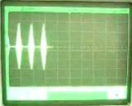 | Power saver off   | Power saver on(Load detected)  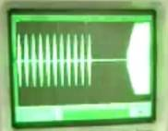

Note: The minimum power of a load to take inverter out of sleep mode (Power Saver On) is 25 Watts.

Idle Power Consumption
Model Type | Power Saver Off |  | Power Saver Auto
Model Type | Idle Power | Quiescent Current | 3Secs(Max) | Unit Off Charge
1KW 12Vdc | 42W | 3.5A | 16W | 2W
1KW 24Vdc | 42W | 1.75A | 16W | 2W
1.5KW 12Vdc | 48W | 4A | 20W | 2W
1.5KW 24Vdc | 48W | 2A | 20W | 2W
2KW 12Vdc | 60W | 5A | 25W | 2W
2KW 24Vdc | 60W | 2.5A | 25W | 2W
2KW 48Vdc | 60W | 1.25A | 25W | 2W
3KW 12Vdc | 72W | 6A | 28W | 2W
3KW 24Vdc | 72W | 3A | 28W | 2W
3KW 48Vdc | 72W | 1.5A | 28W | 2W
4KW 12Vdc | 55W | 2.2A | 20W | 2W
4KW 24Vdc | 52W | 2.1A | 20W | 2W
4KW 48Vdc | 55W | 1.1A | 20W | 2W
5KW 24Vdc | 70W | 2.9A | 25W | 2W
5KW 48Vdc | 70W | 2.9A | 25W | 2W
6KW 24Vdc | 90W | 3.75A | 35W | 2W
6KW 48Vdc | 90W | 1.9A | 35W | 2W

When in the search sense mode, the green power LED will blink and the inverter will make a ticking sound. At full output voltage, the green power LED will light steadily and the inverter will make a steady humming sound. When the inverter is used as an “uninterruptible” power supply the search sense mode function should be defeated.

Exceptions
Some devices when scanned by the load sensor cannot be detected. Small fluorescent lights are the most common example. (Try altering the plug polarity by turning the plug over.) Some computers and sophisticated electronics have power supplies that do not present a load until line voltage is available. When this occurs, each unit waits for the other to begin. To drive these loads either a small companion load must be used to bring the inverter out of its search mode, or the inverter may be programmed to remain at full output voltage.

2.5.7 Protections
The DP series inverter is equipped with extensive protections against various harsh situations/faults.
These protections include:
AC Input over voltage protection/AC Input low voltage protection
Low battery alarm/High battery alarm
Over temperature protection/Over load protection
Short Circuit protection (1s after fault)
Back feeding protection

When Over temperature /Over load occur, after the fault is cleared, the master switch has to be reset to restart the inverter.
The Low battery voltage trip point can be customized from defaulted value of 10VDC to 10.5VDC through the SW1 on the DIP switch.
The inverter will go to Over temp protection when the heat sink temp. ≥105ºC(221℉), and will go to Fault (shutdown Output) after 30 seconds. The switch has to be reset to activate the inverter.
The DP series Inverter is with back feeding protection which avoids presenting an AC voltage on the AC input terminal in Invert mode.
After the reason for fault is cleared, the inverter has to be reset to start working.

2.5.8 Remote control
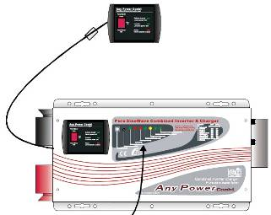
Apart from the switch panel on the front of the inverter, an extra switch panel connected to the remote port at the DC side of the inverter thru a standard telephone cable can also control the operation of the inverter.
If an extra switch panel is connected to the inverter via “remote control port”, together with the panel on the inverter case, the two panels will be connected and operated in parallel.
Whichever first switches from “Off” to “Power saver off” or “Power saver on”, it will power the inverter on.
If the commands from the two panels conflict, the inverter will accept command according to the following priority:
Power saver on> Power saver off> Power off
Only when both panels are turned to “Unit Off” position, the inverter will be powered off.

WARNING
Never cut the telephone cable when the cable is attached to inverter and battery is connected to the inverter. Even the inverter is turned off, this will damage the remote PCB inside if the cable is short circuited during cutting.

2.5.9 LED Indicator & LCD
The operation status of the inverter is shown by the LED’s and the explanation on the LED sticker.
SHORE POWER ON | GREEN LED lighting on AC Mode
INVERTER ON | GREEN LED lighting on Inverter Mode
FAST CHARGE | Yellow LED lighting on Fast Charging Mode
FLOAT CHARGE | GREEN LED lighting on Float Charging Mode
OVER TEMP TRIP | RED LED lighting on Over Temperature
OVER LOAD TRIP | RED LED lighting on Over Load
POWER SAVER ON | GREEN LED lighting on Power Saver Mode (Power Saver Load ≦25W)

The Inverter can be customized into LCD type. The LCD will display the following content:

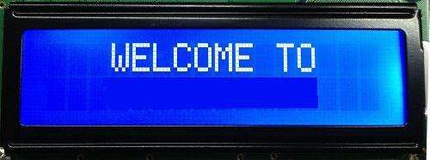
Greeting message of “Welcome to ”
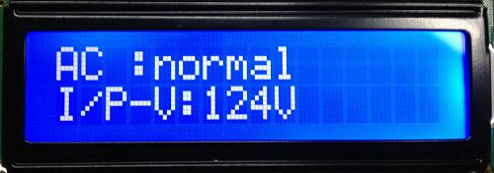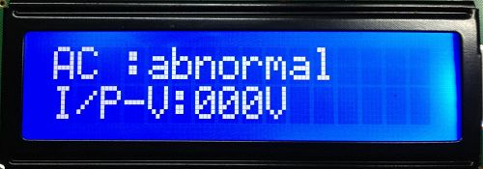
AC Status & Input Voltage
“AC: abnormal” is displayed when AC input is not qualified.
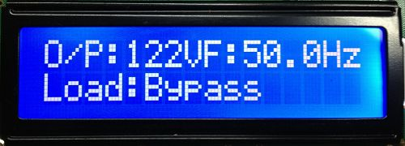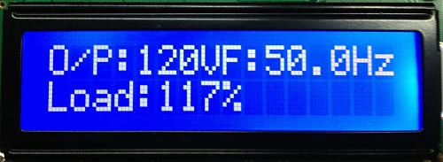
Output Voltage/Frequency and Output Current( in percentage) in Inverter mode
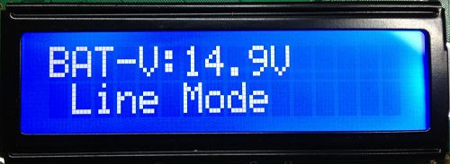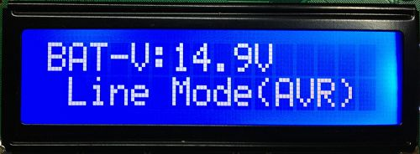
Battery voltage

Or the inverter can be connected to a remote LCD control panel.
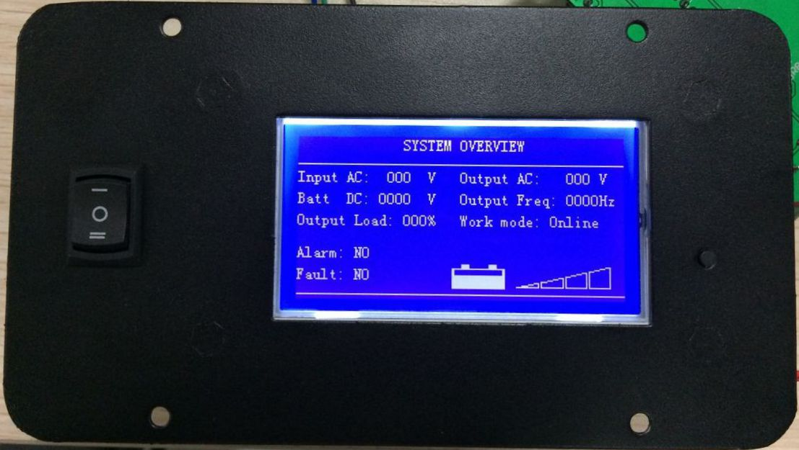

Note:
When the inverter is in Battery Priority mode, “AC:abnormal” will also be displayed when the inverter finishes a complete charging circle and switches to inverter mode.
In AC mode, the LCD will not display the status of AC load.

2.5.10 Audible Alarm
The inverter also gives audible alarms when the following situations occur.
Battery Voltage Low | Inverter green LED Lighting, and the buzzer beep 0.5s every 5s.
Battery Voltage High | Inverter green LED Lighting, and the buzzer beep 0.5s every 1s,  and Fault after 60s.
Invert Mode Over-Load | (1)110%<load<125%(±10%), No audible alarm in 14 minutes,  Beeps 0.5s every 1s in 15th minute and Fault after 15 minutes;  (2)125% <load<150%(±10%), Beeps 0.5s every 1s and Fault after 60s;  (3)Load>150%(±10%), Beeps 0.5s every 1s and Fault after 20s;
Over Temperature | Heat sink temp. ≥105ºC(221℉), Over temp red LED Lighting, beeps 0.5s every 1s;

2.5.11 FAN Operation

For 1-3KW, there is one multiple controlled DC fan which starts to work according to the following logics.
For 4-6KW, there is one multiple controlled DC fan and one AC fan. The DC fan will work in the same way as the one on 1-3KW, while the AC fan will work once there is AC output from the inverter.
So when the inverter is in power saver mode, the AC fan will work from time to time in response to the pulse sent by the inverter in power saver mode.

The Operation of DC fan at the DC terminal side is controlled in the following logic:

Condition | Enter Condition | Leave condition | Speed
HEAT SINK TEMPERATURE | T < 85 ℃(185℉) | T ≥ 85℃(185℉) | 50%
HEAT SINK TEMPERATURE | T ≥ 85℃(185℉) | T < 80℃(176℉) | 100%
CHARGER CURRENT | I ≤ 50%Max | I > 50%Max | 50%
CHARGER CURRENT | I > 50%Max | I ≤ 40%Max | 100%
LOAD Percentage  (INV MODE) | Load < 50% | Load ≥ 50% | 50%
LOAD Percentage  (INV MODE) | Load ≥ 50% | Load ≤ 40% | 100%

Allow at least 30CM of clearance around the inverter for air flow. Make sure that the air can circulate freely around the unit.
Fan noise level <60db at a distance of 1m

2.5.12 DIP Switches
On the DC end of inverter, there are 4 DIP switches which enable users to customize the performance of the device to suit the specific configuration.

Switch NO | Switch Function | Position: 0 | Position: 1
SW1 | Low Battery Trip Volt | 10.0VDC | 10.5VDC
SW1 | Low Battery Trip Volt | *2 for 24VDC, *4 for 48VDC
SW2(230V) | AC Input Range | 184-253VAC | 154-264VAC(40Hz+)
SW2(120V) | AC Input Range | 100-135VAC | 90-135VAC(40Hz+)
SW3 | Load Sensing Cycle & Unit Off charging | Unit Off charging | 3 seconds
SW4 | Battery/AC Priority | Utility Priority | Battery Priority

SW1: Low Battery Trip Volt
Deep discharge of the lead acid battery leads to high losses in capacity and early aging. In different applications, different low voltage disconnection level is preferred. For example, for solar application, user intended to have less DOD to prolong the battery cycle life. While for mobile application, users intend to have more DOD to reduce battery capacity and on board weight.
For 12VDC model, the Low Battery Trip Volt is set at 10.0VDC by default. It can be customized to 10.5VDC using SW1, this is to prevent batteries from over-discharging while there is only a small load applied on the inverter.
*2 for 24VDC, *4 for 48VDC

SW2: AC Input Range
There are different acceptable AC input ranges for different kinds of loads.
For some relatively sensitive electronic devices, a narrow input range of 184-253VAC (100-135V for 120VAC models) is required to protect them.
While for some resistive loads which work in a wide voltage range, the input AC range can be customized to 154-253VAC (90-135V for 120VAC models), this helps to power loads with the most AC input power without frequent switches to the battery bank.
In order to make the inverter accept dirty power from a generator, when the SW2 is switched to position “1”, the inverter will bypass an AC input with a higher voltage(164-264Vac for 230Vac models) and wider frequency (40Hz plus for 50Hz/60Hz). Accordingly, the AC charger will also work in a higher voltage(174-254Vac for 230Vac models) wider freq range (43Hz plus for 50Hz/60Hz).
This will avoid frequent switches between battery and generator. But some sensitive loads will suffer from the low quality power.
The pros and cons should be clearly realized.

SW3: Load Sensing Cycle & Unit Off charging
Under the Battery Priority Mode (SW4 in position “1”), the inverter can be switched between two modes: Power Saver Mode (SW3 in position “1”) and Unit Off Charging Mode (SW3 in position “0”). The power Switch should be in “Power saver on” position all the time for using these functions.
In Power Saver Mode, the inverter is initially in standby mode and sends a pulse to detect the presence of a load every 3 seconds. Each pulse lasts for 250ms. The inverter will remain in standby mode until a load has been detected. Then it will wake up from standby mode and start to invert electricity from the battery bank to supply the load. As this function is under Battery Priority, the inverter will always prefer to invert electricity from battery first even there is a qualified AC input present. Only when the battery voltage is lower than the low voltage alarm point, will the inverter switch to AC input power to charge the battery and supply the load at the same time.
This Power Saver Mode can be changed to Unit Off Charging mode via SW3 by switching it to “0” position.
In Unit Off Charging mode, the inverter will stay in standby mode without sensing loads. It won’t output any power even if a load is turned on or a qualified AC input is present. The inverter will not perform any function and only stay idle in this mode, unless the battery voltage is low. Then it will start charging the battery. This feature is ideally suitable for applications where energy conservation is required. Charging will only be activated when required.

SW4: AC/Battery Priority
Our inverter is designed AC priority by default. This means, when AC input is present, the battery will be charged first, and the inverter will transfer the input AC to power the load. Only when the AC input is stable for a continuous period of 15 days will the inverter start a battery inverting cycle to protect the battery. After 1 normal charging cycle ac through put will be restored. For more info, please refer to our manual at AC Charging Section.
The AC Priority and Battery Priority switch is SW4. When you choose battery priority, the inverter will invert from battery despite the AC input. Only when the battery voltage reaches the low voltage alarm point will the inverter transfer to AC Input, charge battery, and switch back to battery when the battery is fully charged. This function is mainly for wind/solar systems using utility power as back up.
The AC/Battery Priority function can be activated by sliding the switch even when the inverter is in operation.

Note: In battery priority mode, when qualified AC inputs for the first time, the inverter will only go into battery priority mode after a cycle of bulk charging and absorb charging is finished. The inverter will not go into float charging mode.

2.5.13 Other features
Battery voltage recovery start
After low battery voltage shut off(10V for 12V model or 20V for 24V model or 40V for 48V model), the inverter is able to restore to work after the battery voltage recovers to 13V/26V/52V(with power switch still in “On” position). This function helps to save the users extra labor to reactivate the inverter when the low battery voltage returns to acceptable range in renewable energy systems.
WARNING
Never leave the loads unattended, some loads (like a Heater) may cause accidents in such cases.
It is better to shut everything off after low voltage trip than to leave your load in the risk of fire. Nobody wants to return home, finding house surrounded by fire trucks, and naughty neighborhood kids toasting hot dogs against his house.

Auto Gen Start(optional)
The inverter can be customized to start up a generator when battery voltage goes low.
When the inverter goes to low battery alarm, it can send a signal to start a generator, and turn the generator off after battery charging is finished.
The auto gen start feature will only work with generators designed to work with this feature. There is an open/close relay that will short circuit the positive and negative cable from a generator. The input DC voltage can vary, but the Max current the relay can carry is 16Amp.

Conformal Coating
The entire line of inverters have been processed with a conformal coating on the PCB, making it water, rust, and dust resistant.
While these units are designed to withstand corrosion from the salty air, they are not splash proof.

3 Installation

3.1 Unpacking and Inspection
Carefully remove the inverter/charger from its shipping package and inspect all contents.
Verify the following items are included:
·The Inverter/Charger
·Red and black DC terminal covers
·AC terminal block cover with two Phillips screws
·Two Flange nuts and 4 Phillips screws (installed on the DC terminals).
·One Owner’s Manual

If items appear to be missing or damaged, contact our authorized dealer or us. If at all possible, keep your shipping box. It will help protect your inverter from damage if it ever needs to be returned for service. Save your proof-of-purchase as a record of your ownership; it will also be needed if the unit should require warranty work.

3.2 Installation Location
Follow all the local regulations to install the inverter.
Please install the equipment in an INDOOR location of Dry, Clean, Cool with good ventilation.
Working temperature: -10℃ to 40℃(-14℉to 104℉)
Storage temperature: -40 to 70℃(-40℉to 158℉)
Relative Humidity: 0% to 95%，non-condensing
Cooling: Forced air
CAUTION: Some models of the inverters are heavy. Use proper lifting techniques during installation to prevent personal injury.
WARNING!
The inverter should not be installed in an area that allows dust, fumes, insects or rodents to enter or block the inverter’s ventilation openings.
This area also must be free from any risk of condensation, water or any other liquid that can enter or fall on the inverter.
The entire line of inverters has been processed with a conformal coating on the PCB, making it water, rust, and dust resistant.
While these units are designed to withstand corrosion from the salty air, they are not splash proof.
The inverter’s life is uncertain if used in these types of environments, and inverter failures under these conditions are not covered under warranty.

3.3 DC Wiring
It is suggested the battery bank be kept as close as possible to the inverter. The following is a suggested wiring option for 3 meter DC cable.
Please find the following minimum wire size. In case of DC cable longer than 3m, please increase the cross section of cable to reduce the loss.
Power | DC Input voltage | Wire Gage
1KW | 12V | AWG 4
1KW | 24V | AWG 6
1.5KW | 12V | AWG 1/0
1.5KW | 24V | AWG 4
2KW | 12V | AWG 1/0
2KW | 24V | AWG 1/0
2KW | 48V | AWG 6
3KW | 12V | AWG 4/0
3KW | 24V | AWG 1/0
3KW | 48V | AWG 4
4KW | 24V | AWG 1/0
4KW | 48V | AWG 1/0
5KW | 24V | AWG 4/0
5KW | 48V | AWG 1/0
6KW | 24V | AWG 4/0
6KW | 48V | AWG 1/0
Please follow the above minimum wire size requirement.
One cable is always best, but if there is a problem obtaining the recommended size or larger cable, multiple smaller cables will work. Performance of any product can be improved by thicker cable and shorter runs, so if in doubt round up and keep the length as short as possible.

Battery cables must have crimped (or preferably, soldered and crimped) copper compression lugs unless aluminum mechanical lugs are used. Soldered connections alone are not acceptable. High quality, UL-listed battery cables are available .These cables are color-coded with pressure crimped, sealed ring terminals.

Battery terminal must be clean to reduce the resistance between the DC terminal and cable connection. A buildup of dirt or oxidation may eventually lead to the cable terminal overheating during periods of high current draw. Use a stiff wire brush and remove all dirt and corrosion from the battery terminals and cables.
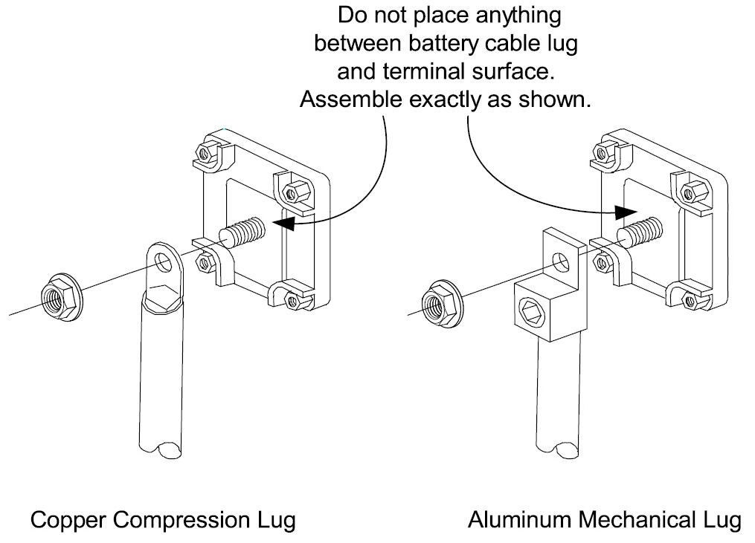
Reducing RF interference
To reduce the effect of radiated interference, twist the DC cables. To further reduce RF interference, shield the cables with sheathing /copper foil / braiding.
Taping battery cables together to reduce inductance
Do not keep the battery cables far apart. In case it is not convenient to twist the cables, keep them taped together to reduce their inductance. Reduced inductance of the battery cables helps to reduce induced voltages. This reduces ripple in the battery cables and improves performance and efficiency.

WARNING | The torque rating range for DC terminal is 12.5NM-20.5NM (9.25-15.19 pound-foot), and the suggested torque rating is 17NM (12.6 pound-foot). Over torquing may break the bolt.
Equipment Damage
The inverter is not reverse polarity protected. Reversing the battery polarity on the DC input connections will cause permanent damage to the inverter which is not covered under warranty. Always check polarity before making connections to the inverter.
 | The inverter contains capacitors that may produce a spark when first connected to battery. Do not mount in a confined compartment with vented battery or gases.
 | Ensure the inverter is off before disconnecting the battery cables, and that AC power is disconnected from the inverter input.

3.4 AC Wiring
We recommend using 10 to 5Awg wire to connect to the ac terminal block.
When in AC mode the AC input power will supply both the loads and AC charger, a thicker wire gauge for AC Input is required. Pls consult a qualified electrician about the specific wire gauge required in terms of wire material and inverter power.

There are 3 different ways of connecting to the terminal block depending on the model. All the wirings are CE compliant, Call our tech support if you are not sure about how to wire any part of your inverter.

Wiring Option 1  230V single phase/120V single phase  Input: Hot line+Neutral+Ground  Output: Hot line+Neutral+Ground | 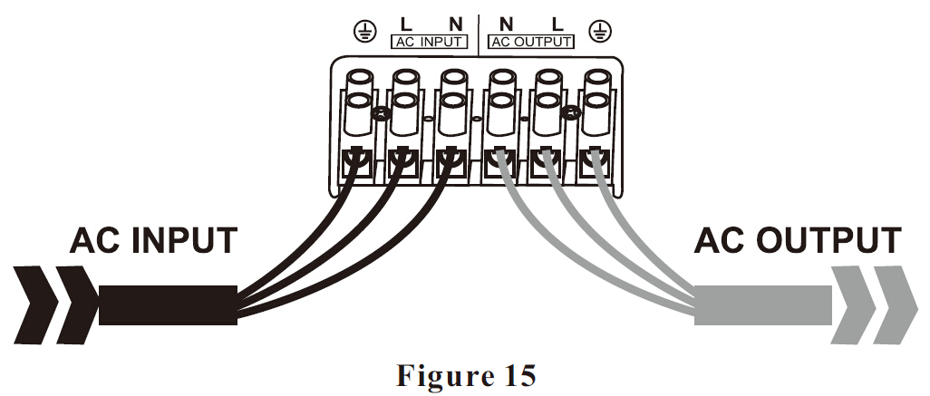
Wiring Option 2  230V split phase  Input: Hot line+ Hot line +Ground  Output: Hot line+ Hot line +Neutral | 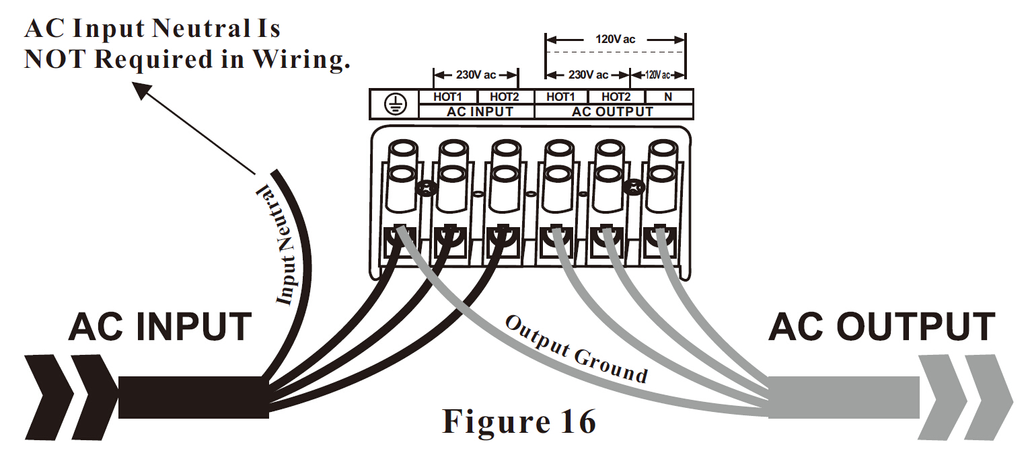
Wiring Option 3  230V split phase  Input: Hot line+ Hot line +Ground  Output: Hot line +Neutral  Remark: In such case, each output hotline can only carry a max of half the rated capacity. | 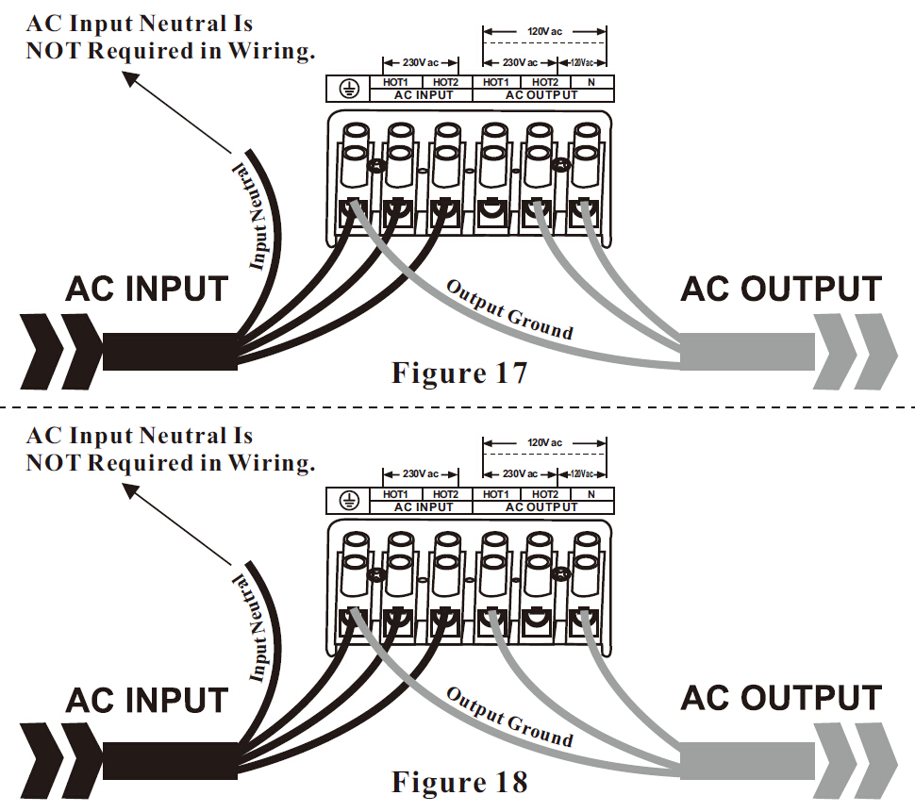

Caution:
Wiring Option 2 and Wiring Option 3 are only allowed for split phase models.
Pls wire all the other models according to Wiring Option 1.

WARNING | For split phase models, AC input neutral is not required in wiring. Never Connect Input Neutral to Ground or to Output Neutral. Damage will result which is not covered under warranty.  The output voltage of this unit must never be connected in its input AC terminal, overload or damage may result.  Always switch on the inverter before plugging in any appliance.  Damages caused by AC wiring mistakes are not covered under warranty.

Preventing Paralleling of the AC Output
The AC output of the unit should never be connected to the utility power / generator.
Such a connection may result in parallel operation of the different power sources and AC power from the utility / generator will be fed back into the unit which will instantly damage the inverter and may also pose a fire and safety hazard.

3.5 Grounding
Connect an AWG 8 gauge or greater copper wire between the grounding terminal on the inverter and the earth grounding system or the vehicle chassis.

3.6 Mounting the Inverter
In order to mount the inverter securely, the surface and the mounting hardware must also be able to support at least twice the weight of the inverter. To meet regulatory safety requirements, the DP Series must be mounted:
1: On a horizontal surface (shelf or table top) with top side up,
2: On a vertical surface (like a wall) with the DC terminals facing left and the fan axis horizontal.
3: On a vertical surface (like a wall) with the DC terminals facing down and the fan axis vertical.
Warning! Don’t mount the inverter upside down.
The inverter surface may get as high as 80℃ (176℉) during operation, do not touch.
The unit should be installed so it is not likely to come into contact with people.

After determining the mounting position, refer to the physical dimensions as shown in below figures or use the base of the inverter as a template to mark your mounting screw locations. After marking the mounting screw locations, mount the unit with appropriate mounting hardware.

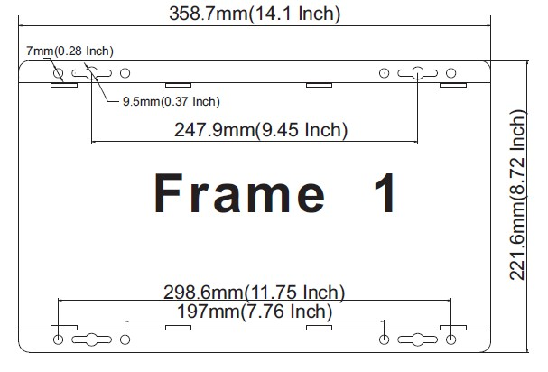 | DP1-1.5KW
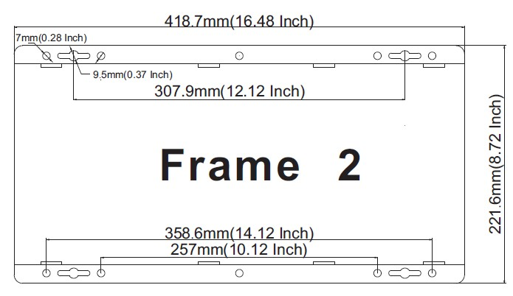 | DP 2-3KW
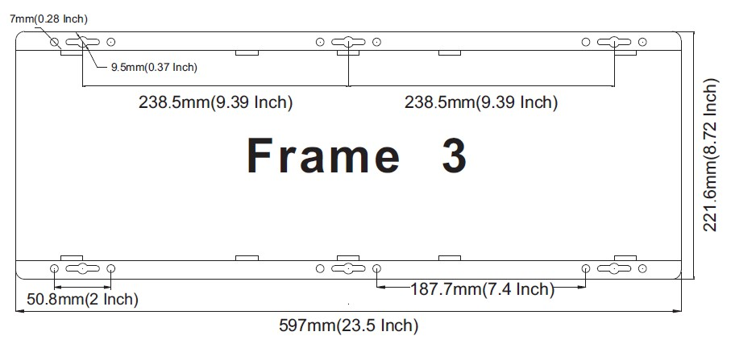 | DP4-6KW
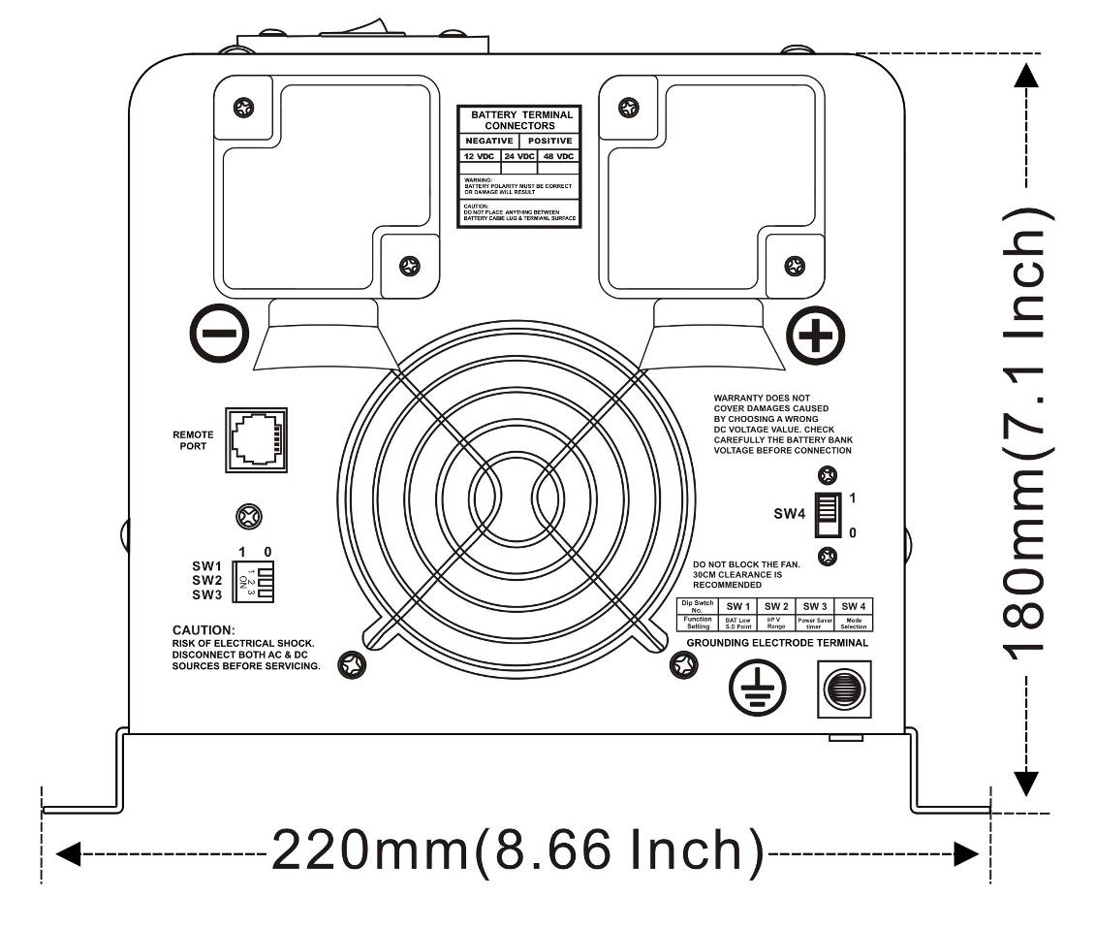 | Side View

4 Troubleshooting Guide
Troubleshooting contains information about how to troubleshoot possible error conditions while using the DPS Inverter & Charger.

The following chart is designed to help you quickly pinpoint the most common inverter failures.

Indicator and Buzzer

 |  | Indicator on top cover |  |  |  |  |  |  | LED on Remote Switch
Status | Item | SHORE POWER ON | INVERTER ON | FAST CHG | FLOAT CHG | OVER TEMP TRIP | OVER LOAD TRIP | POWER SAVER ON | BATT  CHG | INVERTER | Alarm | Buzzer
Line  Mode | CC | √ | × | √ | × | × | × | × | √ | × | × | ×
Line  Mode | CV | √ | × | √, blink | × | × | × | × | √ | × | × | ×
Line  Mode | Float | √ | × | × | √ | × | × | × | √ | × | × | ×
Line  Mode | Standby | √ | × | × | × | × | × | × | × | × | × | ×
Inverter Mode | Inverter On | × | √ | × | × | × | × | × | × | √ | × | ×
Inverter Mode | Power Saver | × | × | × | × | × | × | √ | × | × | × | ×
Inverter Mode | Low Battery | × | √ | × | × | × | × | × | × | √ | √ | Beep 0.5s every 5s
Inverter Mode | High Battery | × | √ | × | × | × | × | × | × | √ | √ | Beep 0.5s every 1s
Inverter Mode | Overload Invert Mode | × | √ | × | × | × | √ | × | × | √ | √ | Refer to “Audible alarm”
Inverter Mode | Over-Temp Invert Mode | × | √ | × | × | √ | × | × | × | √ | √ | Beep 0.5s every 1s
Inverter Mode | Over-Temp Line Mode | √ | × | √ | × | √ | × | × | √ | × | √ | Beep 0.5s every 1s
Inverter Mode | Over Charge | √ | × | √ | × | × | × | × | √ | × | √ | Beep 0.5s every 1s
Fault | Fan Lock | × | × | × | × | × | × | × | × | × | × | Beep continuous
Fault | Battery High | × | √ | × | × | × | × | × | × | √ | × | Beep continuous
Fault | Overload Invert Mode | × | × | × | × | × | √ | × | × | × | × | Beep continuous
Fault | Output Short | × | × | × | × | × | √ | × | × | × | √ | Beep continuous
Fault | Over-Temp | × | × | × | × | √ | × | × | × | × | × | Beep continuous
Fault | Over Charge | × | × | √ | × | × | × | × | √ | × | × | Beep continuous
Fault | Back Feed Short | × | × | × | × | × | × | × | × | × | × | Beep continuous

Symptom | Possible Cause | Recommended Solution
Inverter will not turn on during initial power up. | Batteries are not connected, loose battery-side connections.  Low battery voltage. | Check the batteries and cable connections. Check DC fuse and breaker.  Charge the battery.
No AC output voltage and no indicator lights ON. | Inverter has been manually transitioned to OFF mode. | Press the switch to Power saver on or Power saver off position.
AC output voltage is low and the inverter turns loads OFF in a short time. | Low battery. | Check the condition of the batteries and recharge if possible.
Charger is inoperative and unit will not accept AC. | AC voltage has dropped  out-of-tolerance | Check the AC voltage for proper voltage and frequency.
Charger is supplying a lower charge rate. | Charger controls are improperly set.  Low AC input voltage.  Loose battery or AC input connections. | Refer to the section on adjusting the “Charger Rate”.  Source qualified AC power.  Check all DC /AC connections.
Charger turns OFF while charging from a generator. | High AC input voltages from the generator. | Load the generator down with a heavy load.  Turn the generator output voltage down.
Sensitive loads turn off temporarily when transferring between grid and inverting. | Inverter's Low voltage trip voltage may be too low to sustain certain loads. | Choose narrow AC voltage in the DIP switch, or Install a UPS if possible.
Noise from Transformer/case* | Applying specific loads such as hair drier | Remove the loads

*The reason for the noise from transformer and/or case
When in inverter mode and the transformer and/or case of the inverter sometimes may vibrate and make noise.
If the noise comes from transformer.
According to the characteristics of our inverter, there is one type of load which will most likely to cause rattles of transformer.
That is a half-wave load, load that uses only a half cycle of the power(see figure 1). This trends to cause imbalance of magnetic field of transformer, reducing its rated working freq from 20KHz to, say, maybe 15KHz (it varies according to different loads). This way, the freq of noise falls exactly into the range (200Hz-20KHz) that human ear can sense.
The most common load of such kind is hair drier.
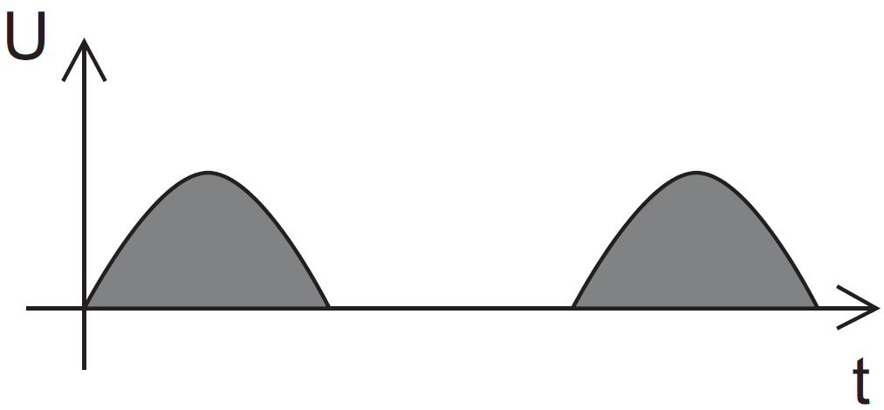
If the noise comes from case.
Normally when loaded with inductive loads, the magnetic field generated by transformer keeps attracting or releasing the steel case at a specific freq, this may also cause noise.
Reducing the load power or using an inverter with bigger capacity will normally solve this problem.
The noise willn’t do any harm to the inverter or the loads.

5 Warranty
We warrant this product against defects in materials and workmanship for a period of two years from the date of purchase and will repair or replace any defective MP Inverter when directly returned, postage prepaid, to manufacturer. This warranty will be considered void if the unit has suffered any obvious physical damage or alteration either internally or externally and does not cover damage arising from improper use such as plugging the unit into an unsuitable power sources, attempting to operate products with excessive power consumption requirements, reverse polarity, or use in unsuitable climates.
WARRANTY DOES NOT INCLUDE LABOR, TRAVEL CHARGES, OR ANY OTHER COSTS INCURRED FOR REPAIR, REMOVAL, INSTALLATION, SERVICING, DIAGNOSING OR HANDLING OF EITHER DEFECTIVE PARTS OR REPLACEMENT PARTS. THE WARRANTOR ASSUMES NO LIABILITY FOR INCIDENTAL OR CONSEQUENTIAL DAMAGES OF ANY KIND.
LOSS OR DAMAGE: Loss or damage in transit is the responsibility of the carrier. Any claim should be filed with the delivering transport company. Invoice, Bill of Lading and Delivery receipt with damage noted therein must accompany any claims for freight damage. Claims for shortage and lost shipments must be made in writing to the shipper within 3 days of the receipt of shipment. Claims not reported within this time frame will not be honored.
This warranty does not apply to and we will not be responsible for any defect in or damage to:
a) the product if it has been misused, neglected, improperly installed, physically damaged or altered, either
internally or externally, or damaged from improper use or use in an unsuitable environment; violations of the warnings in the manual will invalid the warranty.
b) the product if it has been subjected to fire, water, generalized corrosion, biological infestations, or input voltage that creates operating conditions beyond the maximum or minimum limits listed in the product specifications including high input voltage from generators and lightning strikes;
c) the product if repairs have been done to it other than by our company or its authorized service centers;

6 Model Numbering
The DP series Inverter is identified by the model/serial number labels. Model Number label is located on the side of the cover. All the necessary information is provided on the label such as battery voltage, AC output voltage, power and frequency.
For example
Model Number | Power | Battery voltage | AC voltage | Phase
DP1012120 | 1000W | 12Vdc | 120Vac | Single phase
DP2012230 | 2000W | 12Vdc | 230Vac | Single phase
DP4048120230 | 4000W | 48Vdc | 120/230Vac | Split phase
DPS indicates DP series models with voltage regulation.

Appendix 1 DP Series Inverter&Charger

Electrical Specifications
 | Model | 1KW | 1.5KW | 2KW | 3KW | 4KW | 5KW | 6KW
Inverter Output | Continuous Output Power | 1000W | 1500W | 2000W | 3000W | 4000W | 5000W | 6000W
Inverter Output | Surge Rating(20s) | 3000W | 4500W | 6000W | 9000W | 12000W | 15000W | 18000W
Inverter Output | Capable of Starting Electric Motor | 1HP | 1.5HP | 2HP | 3HP | 4HP | 5HP | 6HP
Inverter Output | Output Waveform | Pure Sine wave/Same as input(Bypass mode)
Inverter Output | Peak Efficiency | 88%
Inverter Output | Line Mode Efficiency | >95%
Inverter Output | Power Factor | 0.9-1.0
Inverter Output | Nominal Output Voltage rms | 100-110-120Vac / 220-230-240Vac
Inverter Output | Output Voltage Regulation | ±10% RMS
Inverter Output | Output Frequency | 50/60Hz ± 0.3Hz
Inverter Output | Short Circuit Protection | Yes, Current Limit Function (Fault after 1sec)
Inverter Output | Typical transfer Time | 10ms(Max)
Inverter Output | THD | < 10%
DC Input | Nominal Input Voltage | 12.0Vdc
DC Input | Nominal Input Voltage | ( *2 for 24Vdc, *4 for 48Vdc)
DC Input | Minimum Start Voltage | 10.0Vdc
DC Input | Low Battery Alarm | 10.5Vdc / 11.0Vdc
DC Input | Low Battery Trip | 10.0Vdc / 10.5Vdc
DC Input | High Voltage Alarm & Fault | 16.0Vdc
DC Input | High DC Input Recovery | 15.5Vdc
DC Input | Low Battery voltage recover | 13.0Vdc
DC Input | Sleep Mode Threshold | > 25 W when Power Saver On
Charge | Input Voltage Range | Narrow: 100~135VAC / 194~243VAC;
Charge | Input Voltage Range | Wide: 90~135VAC / 164~243VAC;
Charge | Input Frequency Range | Narrow: 47-55±0.3Hz for 50Hz, 57-65±0.3Hz for 60Hz
Charge | Input Frequency Range | Wide:43±0.3Hz plus for 50Hz/60Hz
Charge | Output Voltage | Depends on battery type
Charge | Charger Breaker Rating(230Vac) | 10A | 10A | 10A | 20A | 20A | 30A | 30A
Charge | Charger Breaker Rating(120Vac) | 10A | 20A | 20A | 30A | 40A | N/A | N/A
Charge | Max Charge Rate | See specific charge rates in “AC Charger” section
Charge | Over Charge Protection Shutdown | 15.7V for 12Vdc ( *2 for 24Vdc, *4 for 48Vdc)
Charge | Battery type | Fast Vdc |  |  |  | Float Vdc
Charge | Gel U.S.A | 14 |  |  |  | 13.7
Charge | A.G.M 1 | 14.1 |  |  |  | 13.4
Charge | A.G.M 2 | 14.6 |  |  |  | 13.7
Charge | Sealed Lead Acid | 14.4 |  |  |  | 13.6
Charge | Gel Euro | 14.4 |  |  |  | 13.8
Charge | Open Lead Acid | 14.8 |  |  |  | 13.3
Charge | Calcium | 15.1 |  |  |  | 13.6
Charge | De-sulphation | 15.5 for 4hrs
Charge | Remote Control | Yes. Optional
Bypass & Protection | Input Voltage Waveform | Sine wave (Grid or Generator)
Bypass & Protection | Nominal Voltage | 120Vac |  |  |  | 230Vac
Bypass & Protection | Low Voltage Trip | 80V/90V±4% |  |  |  | 184V/154V±4%
Bypass & Protection | Low Voltage re engage | 90V/100V±4% |  |  |  | 194V/164V±4%
Bypass & Protection | High Voltage Trip | 140V±4% |  |  |  | 253V±4%
Bypass & Protection | High Voltage re engage | 135V±4% |  |  |  | 243V±4%
Bypass & Protection | Max Input AC Voltage | 150VAC |  |  |  | 270VAC
Bypass & Protection | Nominal Input Frequency | 50Hz or 60Hz (Auto detect)
Bypass & Protection | Low Freq Trip | Narrow: 47±0.3Hz for 50Hz, 57±0.3Hz for 60Hz
Bypass & Protection | Low Freq Trip | Wide:40±0.3Hz for 50Hz/60Hz
Bypass & Protection | Low Freq re engage | Narrow: 48±0.3Hz for 50Hz, 58±0.3Hz for 60Hz
Bypass & Protection | Low Freq re engage | Wide:45±0.3Hz for 50Hz/60Hz
Bypass & Protection | High Freq Trip | Narrow: 55±0.3Hz for 50Hz, 65±0.3Hz for 60Hz
Bypass & Protection | High Freq Trip | Wide: No up limit for 50Hz/60Hz
Bypass & Protection | High Freq re engage | Narrow: 54±0.3Hz for 50Hz, 64±0.3Hz for 60Hz
Bypass & Protection | High Freq re engage | Wide: No up limit for 50Hz/60Hz
Bypass & Protection | Output Short circuit protection | Circuit breaker
Bypass & Protection | Bypass breaker rating (230Vac) | 10A | 15A | 20A | 30A | 30A | 40A | 40A
Bypass & Protection | Bypass breaker rating (120Vac) | 20A | 20A | 30A | 40A | 50A | N/A | N/A
Mechanical Specification | Mounting | Wall/Ground mount
Mechanical Specification | Inverter Dimensions(L*W*H) | 382*218*179mm |  | 442*218*179mm |  | 598*218*179mm
Mechanical Specification | Inverter Dimensions(L*W*H) | 15*8.5*7” |  | 17.5*8.5*7” |  | 23.5*8.5*7”
Mechanical Specification | Inverter Weight | 16KG | 17KG | 20KG | 24KG | 35KG | 44KG | 45KG
Mechanical Specification | Inverter Weight | 35.27lbs | 37.48 lbs | 44.1 lbs | 52.91 lbs | 77.16 lbs | 97 lbs | 99.21 lbs
Mechanical Specification | Shipping Dimensions(L*W*H) | 530*325*315mm |  | 595*330*320mm |  | 800*360*350mm
Mechanical Specification | Shipping Dimensions(L*W*H) | 20.75*12.75*12.5” |  | 23.5*13*12.5” |  | 30.5*14.25*13.75”
Mechanical Specification | Shipping Weight | 18KG | 19KG | 22KG | 26KG | 37KG | 46KG | 47KG
Mechanical Specification | Shipping Weight | 39.68 lbs | 41.89 lbs | 48.51 lbs | 57.32 lbs | 81.57 lbs | 101.41 lbs | 103.61 lbs
Mechanical Specification | Display | Status LEDs
Mechanical Specification | Standard Warranty | 1 Year

※Specifications in this manual are subject to change without prior notice.

Save This Manual!
Read this manual before installation, it contains important safety, installation and operating instructions. Keep it in a safe place for future reference.
WE WISH YOU A PLEASANT EXPERIENCE IN USING OUR INVERTERS.

